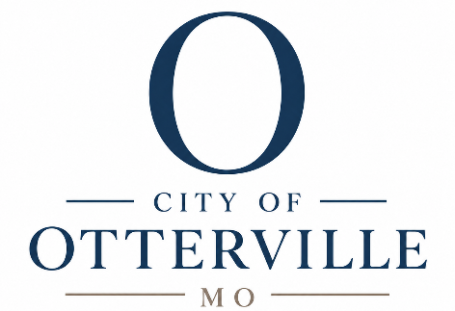

203 BB Highway PO Box 58 Otterville, MO 65348 660.366.4613 ottervillecityclerk@ottervillemo.gov
Posted

August 19th 2026 12:05 PM
Agenda
Board of Alderman
Public Hearing
City of Otterville 2026 tax levy
Where: City Hall
When: Wednesday, August 26th, 2026
6:00 PM
- Roll call Sean Main roll call
- Explanation tax levy Information
- Public Comments
- Tax Levy Sean Main Vote
- Meeting Adjourned Sean Main roll call

